Merit Badge

Counselor

Training
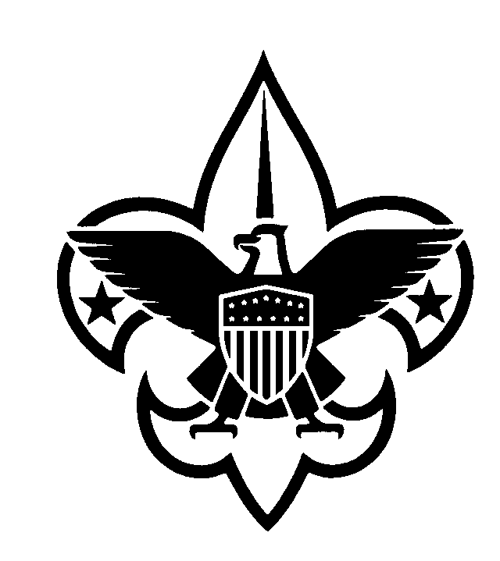

Prepared by: Robert C. Warner
Piedmont District
Blue Ridge Mountains Council

Original Edition: September 1, 1995
Revision 1: September 1, 1998
Revision 2: October 13, 1998
Revision 3: December 3, 1999
Revision 4: January 20, 2000
Revision 5: April 21, 2001
Revision 6: January 25, 2002
Revision 7: November 1, 2002
Revision 8: March 10, 2003

Originally prepared as a training program for the Merit Badge Counselors in Piedmont District. Revisions 2, 3 and 4 and the accompanying Power Point program and slides were prepared in fulfillment of the requirements for the Triad Commissioner of Science Doctoral Program. Presented at the Blue Ridge Mountains Council 1998 University of Scouting on November 7, 1998, at the 1999 University of Scouting on December 4, 1999, and again at the 2001 University of Scouting on February 3, 2001. Revision 5 converted the format to MSWord in preparation for posting on the United States Scout Service Project website. Revision 6 was prepared for the Blue Ridge Mountains Council 2002 (Winter) University of Scouting on February 2, 2002. Revision 7 was prepared for the Blue Ridge Mountains Council 2002 University of Scouting on November 2, 2002 (Fall). Revision 8 was prepared to support requests out of BRMC and update and expand the “Library” section.

For comments, questions or corrections, please contact Bob Warner: email: rcwscouts@aol.com; land line: (434) 384-6306; or snail mail: 5313 Hickory Hill Drive, Lynchburg, VA 24503

Table of Contents

Description Page
Objective 1
Reasons 2
Merit Badge Program Quiz 3
The Administrative 5
Merit Badge Counselors--Their Approval and Listing 6
The Award 8
What is a Merit Badge? 9
Career Fields 10
Merit Badge Counselor Requirements 11
Requirements for a Merit Badge Counselor 12
The Purpose of Scouting 13
To Achieve this Purpose 14
Religious Principles 15
Boy Scout Advancement Procedure 16
Purpose of The Review 17
What the Board of Review Learns about the Merit Badge Program 18
The Merit Badge Process 19
The Merit Badge Process 20
The Merit Badge Process--Group 22
Counseling Techniques 23
Merit Badge Library 24

Merit Badge Pamphlet and Merit Badge Requirement Revision Dates 27

Objective:

"All Merit Badge Counselors must be trained in the aims of Scouting and in advancement procedures."

"The district or council advancement committee should train counselors either as a group or individually."

Advancement Committee
Policies and Procedures
Reasons:

Knowledge

Understanding

Uniformity

Vision

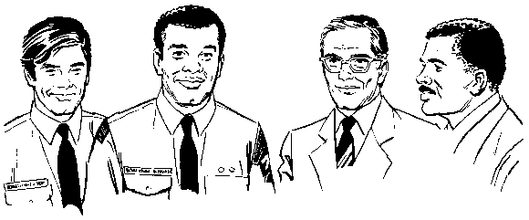

MERIT BADGE PROGRAM QUIZ
[Test your knowledge of the BSA Merit Badge Counselor Program]

1. A Merit Badge Counselor may only be a counselor for four Merit Badges. T F

2. A Merit Badge Counselor may only be a counselor for six Merit Badges. T F

3. A Merit Badge Counselor may not coach his own son or close relative
(i.e., nephew) unless he is part of a group of Scouts all working on the
same Merit Badge. T F

4. A Merit Badge Counselor who works only with a single unit needs only
the unit committee chairman's and chartered organization representative's
approval before being approved by the Scout Executive. T F

5. Persons serving as Merit Badge Counselors must be registered as a
Merit Badge Counselor with the Boy Scouts of America. T F

6. Registered Scoutmasters and Assistant Scoutmasters who also serve as
Merit Badge Counselor do not need to separately re-register as a Merit
Badge Counselor. T F

7. A Scout may earn no more than six Merit Badges from the same Merit
Badge Counselor. T F

8. Once a Scouter is approved as a Merit Badge Counselor, he is approved
for life and never has to be reapproved again. T F

9. A unit Board of Review may approve the awarding of a Merit Badge in lieu
of an approved Merit Badge Counselor. T F

10. A Scout must complete all the requirements for a Merit Badge within
12 months or he must start over. T F

11. A Merit Badge Counselor may take the Scout beyond the specific
requirements of the Merit Badge so he may discover more about the
subject and continue the learning process. T F

12. Due to the BSA policies related to child protection and two deep
leadership, a Merit Badge Counselor must have another adult present
during all Merit Badge Counseling sessions. T F

13. A Merit Badge Counselor for scoutcraft areas such a Pioneering Cooking,
Hiking and Camping must accompany the Scout on these activities;
therefore, it is usually more appropriate for the Scoutmaster or an Assistant Scoutmaster to be the Merit Badge Counselor. T F

14. There is a training program for Merit Badge Counselor. T F

15. A unit Board of Review, at the option of the Advancement Chairman, may
examine a Scout on any part of a completed Merit Badge. T F

16. If because of the weather, locale, or some other condition makes meeting
all of the conditions of the Merit Badge requirements impractical, the Merit
Badge Counselor with his greater pool of skill and knowledge in the area
may substitute requirements for those stated for the Merit Badge. T F

17. Merit Badge Counselors must be at least _____ years old. _____

18. The four steps in the advancement and Merit Badge program (1)___________
are: (1)______________, (2)______________, (2)___________
(3)______________, and (4)______________, (3)___________
(4)___________

19. The requirements for a Merit Badge on the Eagle required list has one set
of requirements in the Scout's The Boy Scout Handbook, a different set in
the Merit Badge Pamphlet, and a third set in the Boy Scout Requirements,
current edition. What should the Merit Badge Counselor do? _____________

- Use the set in the Scout's The Boy Scout Handbook because those are the ones in effect when the Scout joined the Boy Scouts.
- Use the set in the Merit Badge Pamphlet since that is the official publication for the Merit Badge.
- Create an optimum set of requirements by combining the requirements of all three publications.
- Use the requirements as listed in the Boy Scout Requirements.

20. A Merit Badge Counselor must present: (1)______________, (1)___________
(2)______________, (3)______________, (2)___________
and (4)______________ (3)___________
(4)___________
The

Administrative
MERIT BADGE COUNSELORS--THEIR APPROVAL AND LISTING

The following are salient points from the BSA’s "Advancement Committee Policies and Procedures," Publication 33088D, 2002 Printing, relating to the approval and listing of Merit Badge Counselors. These points include BSA requirements for the District and the Council.

"Article X. Program (Advancement)--Rules and Regulations, Clause 13:
"The responsibility for merit badges shall rest with the merit badge counselor approved by the local council..." (p 17) NOTE: Misprint omitted last line.

"Responsibilities of the Council Advancement Committee:
"Approve merit badge counselors and publish council and/or district merit badge counselor lists." (p 5)

"Promoting Advancement:
"Special civic, industrial, and retail contacts can be made on a council level that could expedite recruiting counselors,...not preempt the district committee responsibilities, but rather enhance and provide the district committee and units with resources that would not otherwise be available to them." (p 7)

"Advancement in Summer Camp:
"The procedures should be established, in writing, by the council advancement committee in cooperation with the camp director or program director prior to the beginning of camp." (p 7)

“What is Advancement?:
"No council, district, unit, or individual has the authority to add or subtract from advancement requirements." (p 3)

"Approving Merit Badge Counselors and Publishing List of Counselors:
"The council advancement committee is responsible for approving merit badge counselors.” (p 7)

"The council advancement committee reviews the district merit badge [counselors] list and has it published at least once a year by the council service center." (p 7)

"Qualifications of Counselors:
"Register merit badge counselors by using the basic adult registration form. All merit badge counselors must be approved by the council advancement committee." (p 13)

Merit Badge counselors”…must be approved by the committee for each specific merit badge.” (added by Rev. D, 33088, p 13)

The following is not in the current publication. However, the form (34405) is still available.
The Merit Badge Counselor Information sheet is used by district or council advancement committees in determining the qualifications of persons to serve as merit badge counselors.

"Maintaining a Current List of Merit Badge Counselors:
"The district or council list of counselors should be reproduced for distribution to troops... When changes are made, these should be sent promptly to the units … so that all units have readily available the names, addresses and phone numbers of counselors. Lists are updated at least once a year, usually when councils and districts reregister. (p 13)

"Merit badge counselors (Code 42) are registered with the local council. As with all council members, their registration must be renewed annually.” (p 14)

"As part of the local council charter renewal process, the council advancement committee sends a letter to existing merit badge counselors who are to continue for another year. This provides the council an opportunity, at least annually, to assure that their merit badge counselor lists are updated. This also is an excellent opportunity to not reregister those persons identified as not following the policies and procedures of the Boy Scouts of America." (p 14)

"Troop...Merit Badge Counselors:
"All merit badge counselors, even those who serve only one unit, must be approved by the council and district advancement committee, and counselors must register as a merit badge counselor." (p 14)

"Advancement Committee Policies and Procedures," also states that the council compiles “a monthly District Advancement Report Summar(ies)..." and includes this summarization "...on the Application for Renewal of the Local Council Charter.” (p 6)

Noted in its deletion:
and that the District Advancement Committee should refer "to copies of the past few council charter renewals..." to determine which "...merit badges are most popular."
The

Award
What is a Merit Badge?

- an award based on completing a set of specific requirements
- a small piece of khaki cloth with a colored design
- the significant interest of an adult in helping a boy
- a subject of interest to a Scout
- a subject of interest to an adult
- a subject required to reach the Eagle rank
- a craft or hobby
- an idea of service
- a vocational field
Career Fields

- vital impact on the life of a Scout
- may involve service clubs, unions or professional societies
- professional society members can be Merit Badge Counselors
- professional societies can help recruit and train Merit Badge Counselors
Merit Badge

Counselor

Requirements
Requirements for a Merit Badge Counselor

- Must possess the moral, educational and emotional qualities

- Must be at least 18 years old

- May be a citizen of the USA; or a noncitizen if in the US or a territory or country under the control of the US
[this requirement was changed in the Rules and Regulations (January 2003),
Article VIII, Section 2 and on the Adult Application under Qualification]

- Subscribe to:

- the Declaration of Religious Principles
- the Scout Oath or Promise
- the Scout Law

- Have unique skills and education or experience or knowledge in the subject

- Have the interest to turn a color-embroidered piece of khaki cloth into something of significance for a Scout to want to earn it.

- Must complete an Adult Application with a Position Code of "42" and the Merit Badge Counselor Information (MPCI) form

- Must be approved by:

- the District Advancement Committee
- the Scout Executive or his designee
- the Council Advancement Committee
The Purpose of Scouting

- to promote, through cooperation with other agencies:

the ability of youth to do things for themselves and others

- to teach youth patriotism, courage, self-reliance and kindred virtues
To achieve this purpose

emphasis is placed on:

educational program

oaths, promises and codes

for:

character development

citizenship training

mental fitness

physical fitness
Religious Principles

1. Does not define what constitutes a belief in God or the practice of religion

2. Does not require membership in a religious organization

3. Does prefer and strongly encourage membership and participation in the religious programs and activities of a religious organization

4. Respects the convictions of those who exercise their constitutional freedom to practice religion

5. The standards by which a Scout's membership in a religious body is evaluated are those of that body. Therefore, an Eagle applicant must provide a reference from his religious leader to indicate whether he has lived up to their body's expectations

Advancement Committee Policies and Procedures as an interpretation of Article IX,
Section 1, Clause 1 of Charter and By Laws of the Boy Scouts of America (p 16)
Boy Scout Advancement Procedure

1. Learning

2. Testing

3. Reviewing

4. Recognition
Purpose of The Review

1. To make sure that the work has been learned and completed

2. To check to see what kind of experience the boy is having in his patrol and troop

3. To encourage the Scout to advance to the next level

THE REVIEW IS NOT AN EXAMINATION

Appropriate questions:

- where did he learn his skill

- who taught him

- what value did he gain from earning this recognition
What the Board of Review Learns about the Merit Badge Program

- Did the Scout do what he was suppose to

- What kind of experience is the Scout having

- What changes need to be made in the program

- What are the Scout's ideals and goals

- Is there a good standard of performance

- Does the Scout recognize and understand the value of Scouting in his home, unit, school and community
The

Merit Badge

Process
The Merit Badge Process

- A Scout is guided to the requirements for a Merit Badge.

- The Scout finds the requirements in:

- Boy Scout Requirements

B. Merit Badge Pamphlet, at:

- . the Troop Library
- the public library
- a friend (peer)
- a friend (adult)
- a local store stocking Scout supplies
- a Scout store or trading post

C. Internet

- The Scout looks at the requirements and decides he wants to pursue the Merit Badge.

- The Scout indicates his interest in a particular Merit Badge to his Scoutmaster, who:

A. gives him an interview to determine interest, enthusiasm, and preparedness

- gives him a signed Application for Merit Badge

- with the District Merit Badge Counselor List, helps the Scout locate the name and phone number of the district/council approved Merit Badge Counselor

- encourages the Scout to wear his Class A uniform when he visits the counselor with his buddy

- The Scout telephones the Merit Badge Counselor and makes an appointment.

- The Merit Badge Counselor sets the date and time for the Scout and his buddy and suggests the Scout:

bring the Merit Badge Pamphlet

- bring the Application for Merit Badge

- prepare by reading over the requirements and start working on some of the areas

- bring the work he has started or accomplished

- bring any other materials he may need

- bring any other documentation he may have

- The Merit Badge Counselor verifies the current requirements for the Merit Badge.

- At the first meeting, the Merit Badge Counselor and the Scout decide upon:

- any projects that will be required (write these out)

- a tentative schedule for completing the requirements both short-term and long-term, keeping the other obligations (Scout, school, church, etc.) in mind (write these completion date goals out)

- dates, times and location for future meetings

- The number of counseling sessions depend on the difficulty of the Merit Badge requirements and the preparation and ability of the Scout.

- The Scout is expected to meet the requirements for the Merit Badge as stated--no more and no less.

- The Scout is coached and encouraged with a buddy present. The Merit Badge Counselor may expand on the information in the Merit Badge Pamphlet based on his knowledge, experience and expertise in the subject. He is encouraged to tell about his own experiences that positively reinforce the subject matter of the Merit Badge requirements.

- The Merit Badge Counselor assists the Scout to meet the requirements.

- The Scout is always tested individually, but with a buddy present, and as each requirement is completed the Merit Badge Counselor marks it on the application.

- The Merit Badge Counselor certifies when the Scout has completed the requirements and hardily congratulates him on completing the requirements.

- When possible, the Merit Badge Counselor attends the Court of Honor when the Scout receives public recognition of his accomplishment.
The Merit Badge Process--Group

- Either the troop committee, the Patrol Leader Council (PLC) or the district (i.e., Merit Badge College) decides to offer a Merit Badge to the entire troop or a group of Scouts (avoid Merit Badge factories).

- A Merit Badge Counselor is selected using the District Merit Badge Counselor List and a tentative schedule is developed in mutual accord between the counselor and the troop or district leadership.

- The Merit Badge Counselor develops the presentations and a learning aid handout. Individual sessions should usually be limited to 30 minutes at Troop meetings. Games are useful in developing the knowledge, skills and enthusiasm for the Scouts and should be liberally used.

- The Merit Badge Counselor should go over the requirements with the Scouts at the initial meeting and define his expectations for meeting each requirement with a positive outlook (don't forget to consider the age dichotomy within the troop).

- Some or all testing may be accomplished by written tests. Remaining requirements must be done on an individual basis.

- Some sessions may utilize guest experts to add variety. Also visual and tactile aids help stimulate interest and attention.
Counseling Techniques

- Scout must feel welcome and relaxed.

Techniques:

- Stimulate the Scout's interest by showing him something related to the Merit Badge subject (don't overwhelm the Scout--remember he's probably a beginner).

- Start the Scout with easy skills or questions.

- Carefully review each requirement.

- Insist that the Scout do exactly what the requirements call for:

Show or Demonstrate
Make
List
In the field
Collect, identify and label

- Don't increase the requirement.

Scout may undertake more activities on his own initiative (encourage without pushing him off course).

- During testing, the Merit Badge Counselor may find the Scout needs help learning a particular area. The Merit Badge Counselor teaches the needed skill, but then retests to ensure the area has been learned.

- Encourage practice.

- Follow up.

- Encourage self-evaluation (reflection).

- Establish an atmosphere that encourages the Scout to ask for help.

- Take a genuine interest in the Scout's projects and encourages completion.

